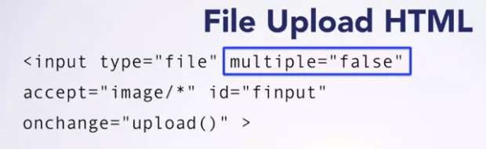

We don’t have to use <button> as File Input Type already has it init.

**Input Type File**

The <input type="file"> defines a file-select field and a "Browse" button for file uploads.

<form>  
  <label for="myfile">Select a file:</label>  
  <input type="file" id="myfile" name="myfile">  
</form>